Unit 5 Lister Park Industrial Estate, Green Lane, Featherstone, WF7 6FE

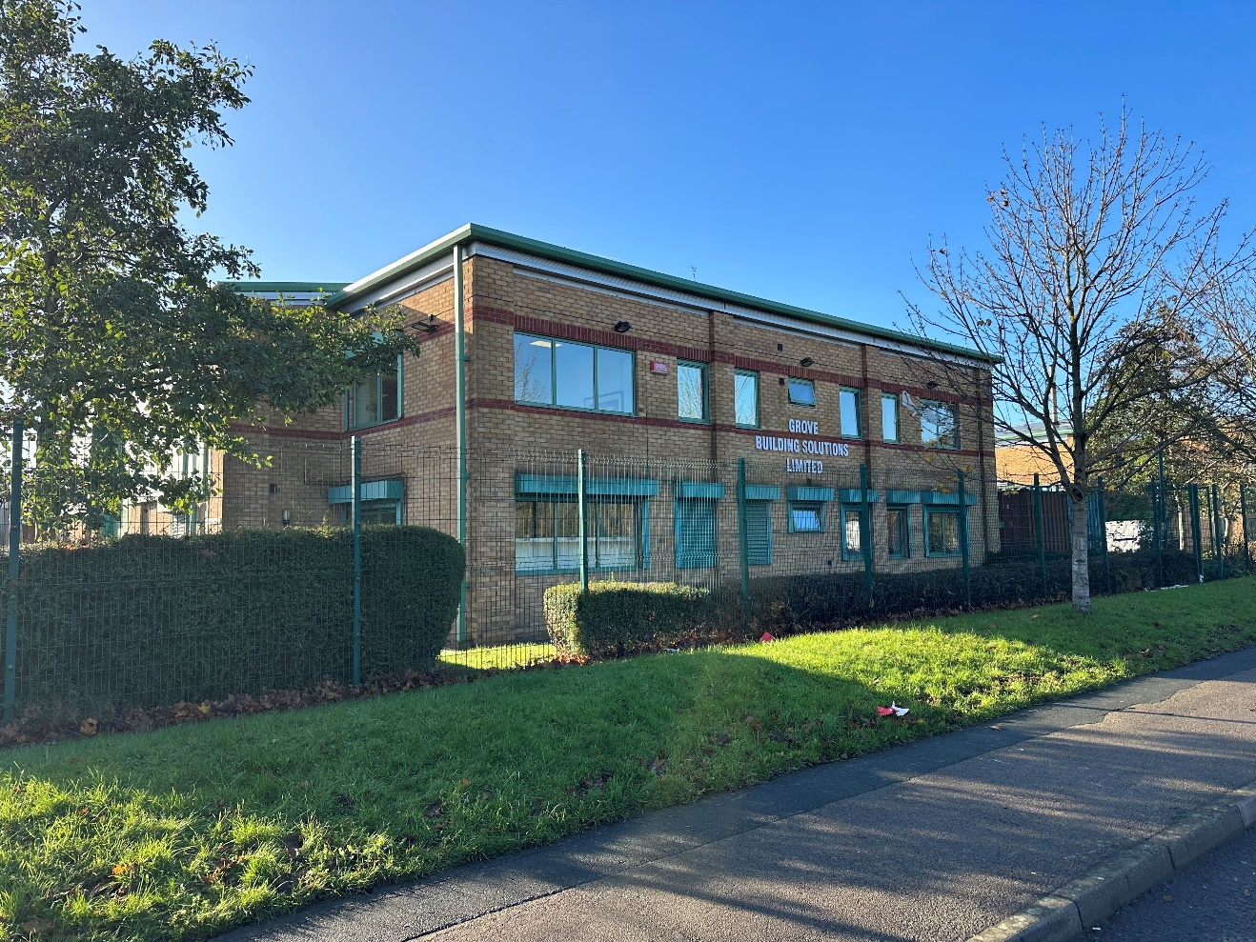

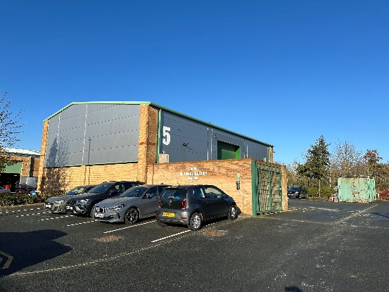

# Investment Property For Sale
# Modern Industrial Unit with Offices
# Currently Let on Full Repairing Insuring Lease
# Current Rent - £45,000 per annum exclusive
# Includes car parking
# Energy Rating ‘D84’

PRICE

£550,000 plus VAT

Description
We are pleased to offer for sale this investment opportunity to purchase this modern Detached Industrial Unit situated within a convenient location within Green Lane Industrial Estate. Occupies a prominent position off Green Lane, the property is currently let on a full repairing and insuring lease to Grove Building Solutions Ltd at an annual rent of £45,000 per annum exclusive. The lease is for a term of 3 years commencing on the 4th August 2023.

The current tenant company has occupied the building for a number of years.

RATEABLE VALUE
The building has a rateable value under the 2023 rating list of £35,250.

RENT
Current rental income - £45,000 per annum exclusive.

LEASE TERMS
3 years from the 4th August 2023 on full repairing and insuring terms.

PRICE
£550,000 plus VAT

VIEWING
Strictly by prior appointment with the Agents Abson Blaza Property Services 01977 780599.

NOTE TO PROSPECTIVE PURCHASERS:
Room measurements & Floor Plans:
All room measurements are approximate and are usually taken at their widest point. Floor plans are intended as a guide only and are not to scale. We cannot confirm the accuracy of these plans.
Tenure & Boundaries:
We cannot confirm the Tenure of the property and the boundaries and ownership have not been checked on the Title Deeds for any discrepancies or for any rights of way. All prospective purchasers should make their own enquiries before proceeding to exchange of contracts.
Services:
None of the services and equipment have been tested and no warranties of any kind can be given accordingly, prospective purchasers should bear this in mind when formulating their offers. The sellers do not include in the sale any carpets, light fittings, floor covering, curtains, blinds, furnishing, electrical/gas appliances (whether connected or not) or any other fixtures and fittings unless expressly mentioned in these particulars.
Additional Information:
The information contained within these particulars are intended as a guide to prospective purchaser(s) and neither Abson Blaza Property Services not the Vendor(s) accept any liability for their accuracy. Prospective purchasers should satisfy themselves by inspection or otherwise as to the correctness pf the information therein. They do not constitute any part of an offer or contract. All negotiations to be conducted through the Sole Agents – Abson Blaza Property Services.

